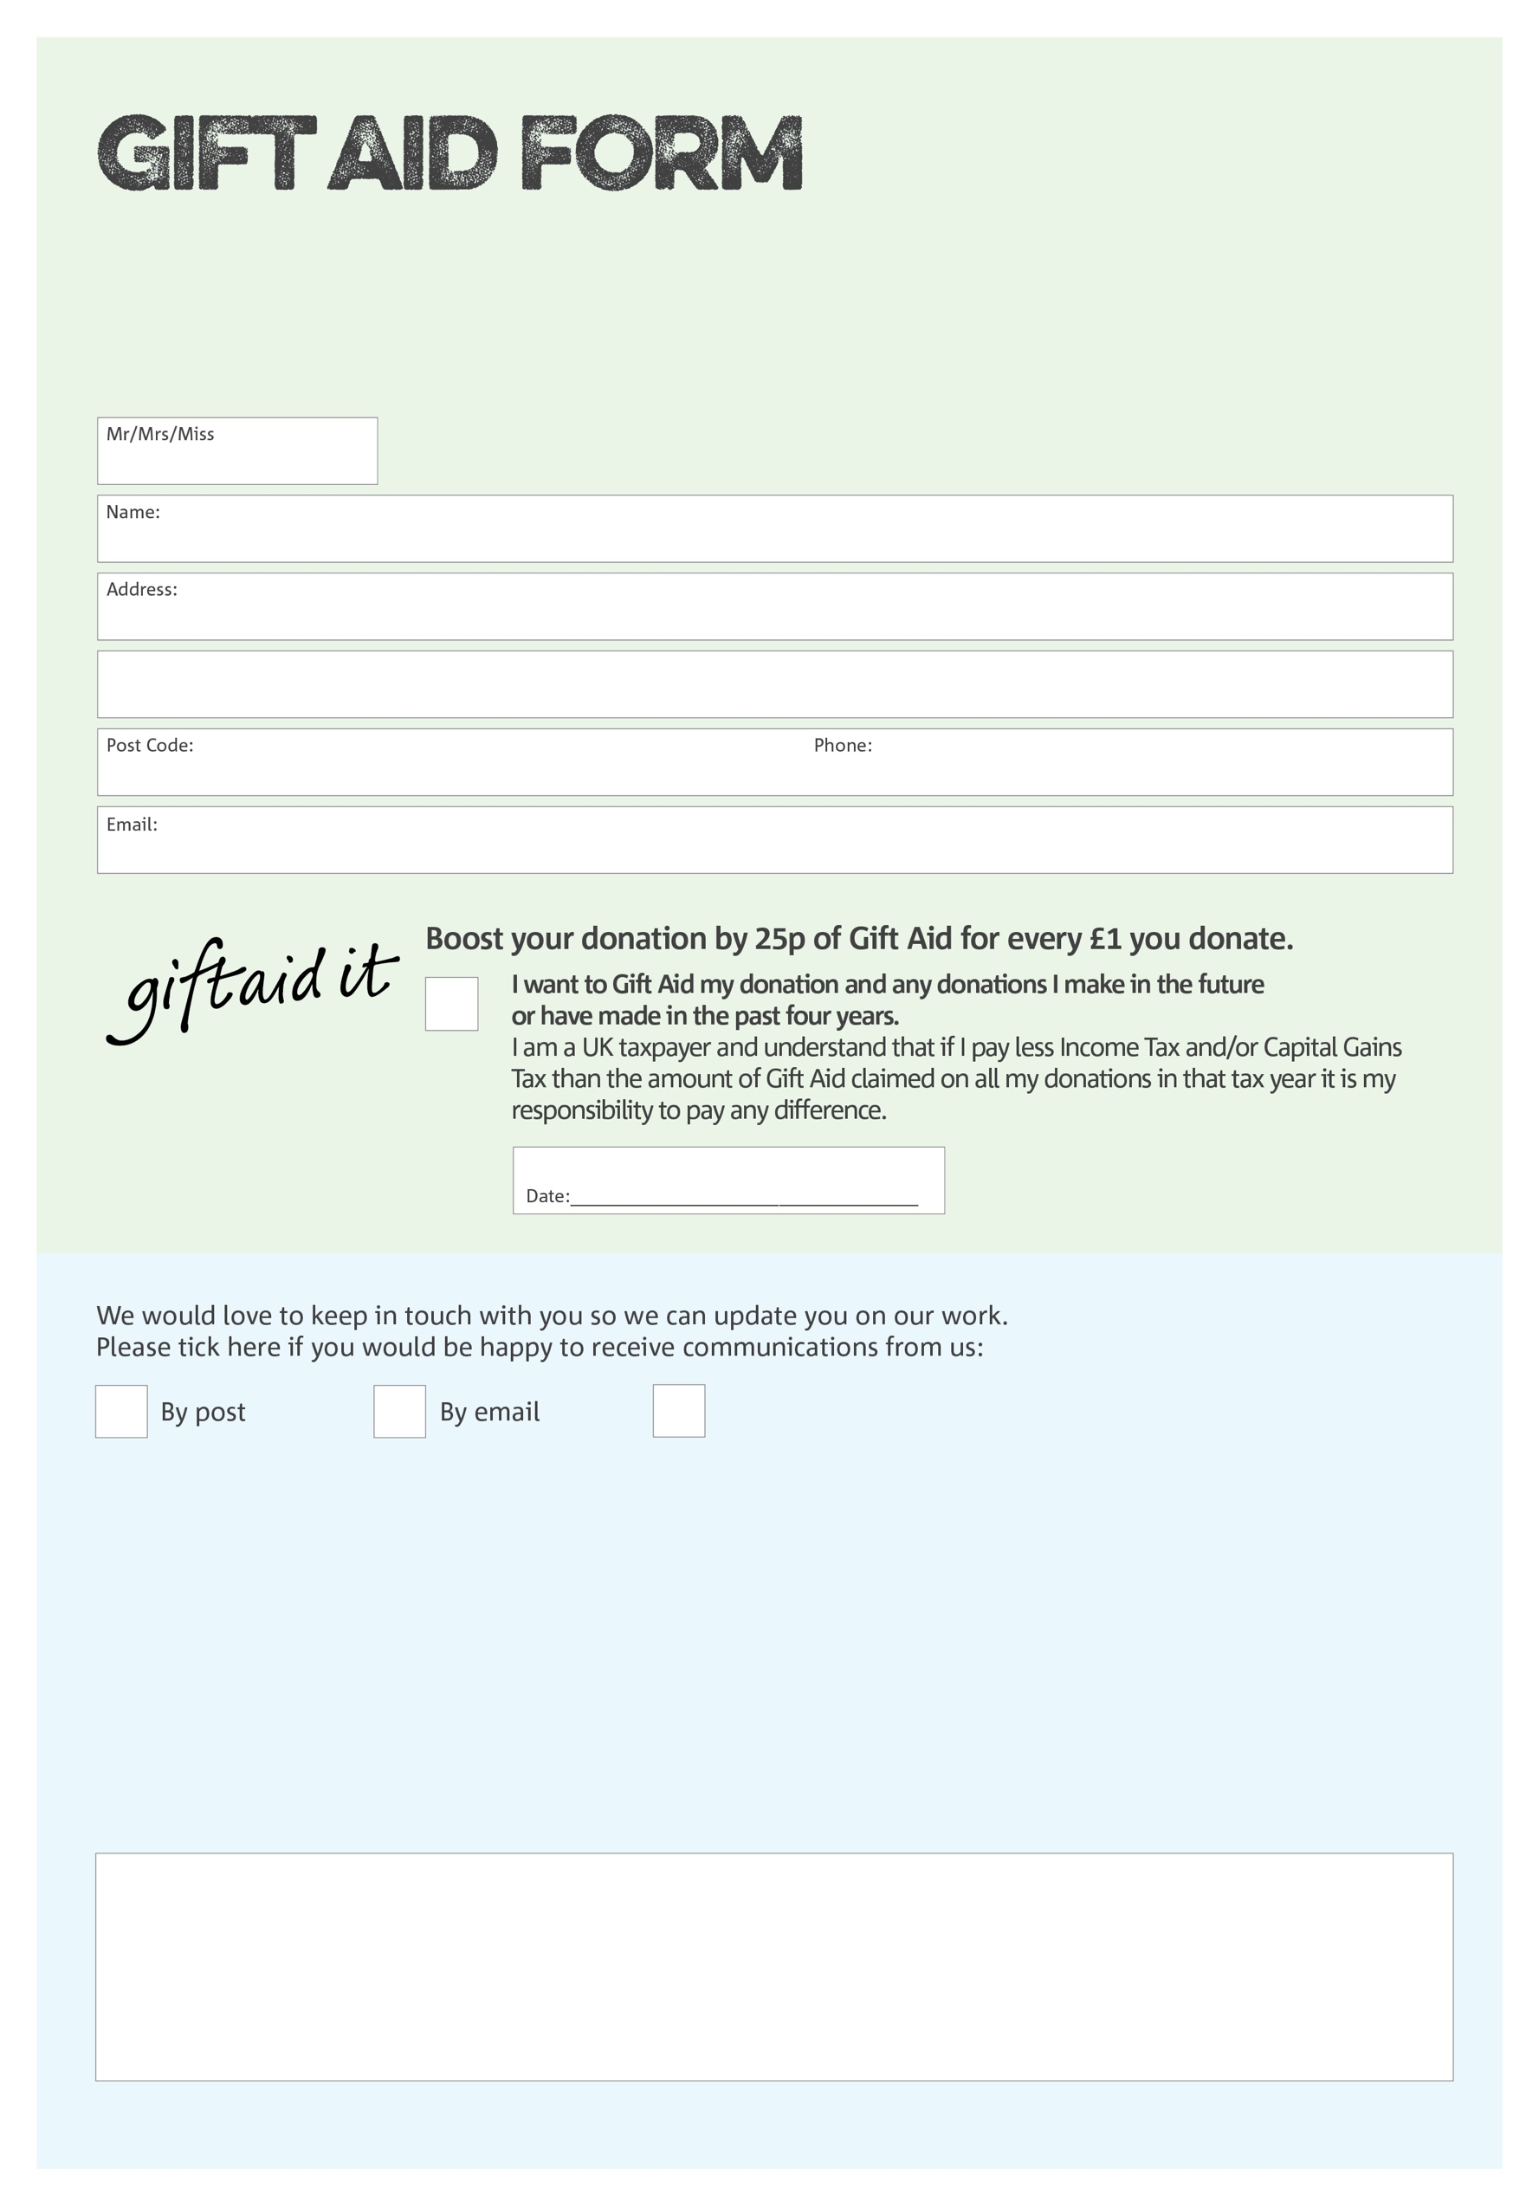

By filling in this form Clevedon District and Foodbank CIO will receive an extra 25p for every £1 you give at no extra cost to you. Thank you!

You can change your preferences any time by contacting us on 07722769529 or emailing us at

info@clevedondistrict.foodbank.org.uk

I do not wish to receive future communications from Clevedon and District Foodbank CIO

**Data protection**

Clevedon District Foodbank CIO is committed to protecting your privacy and will process your personal data in accordance with the Data Protection Act 1998. Clevedon and District Foodbank CIO collects information to keep in touch with you and supply you with information relating to our work. Clevedon and District Foodbank CIO will never sell or pass your details to anyone who isn’t directly working on our behalf.

We would love to know why you have chosen to donate to Clevedon and District Foodbank CIO If you would like to share your motivation let us know below:

Charity Number 1163153 Registered in England and Wales