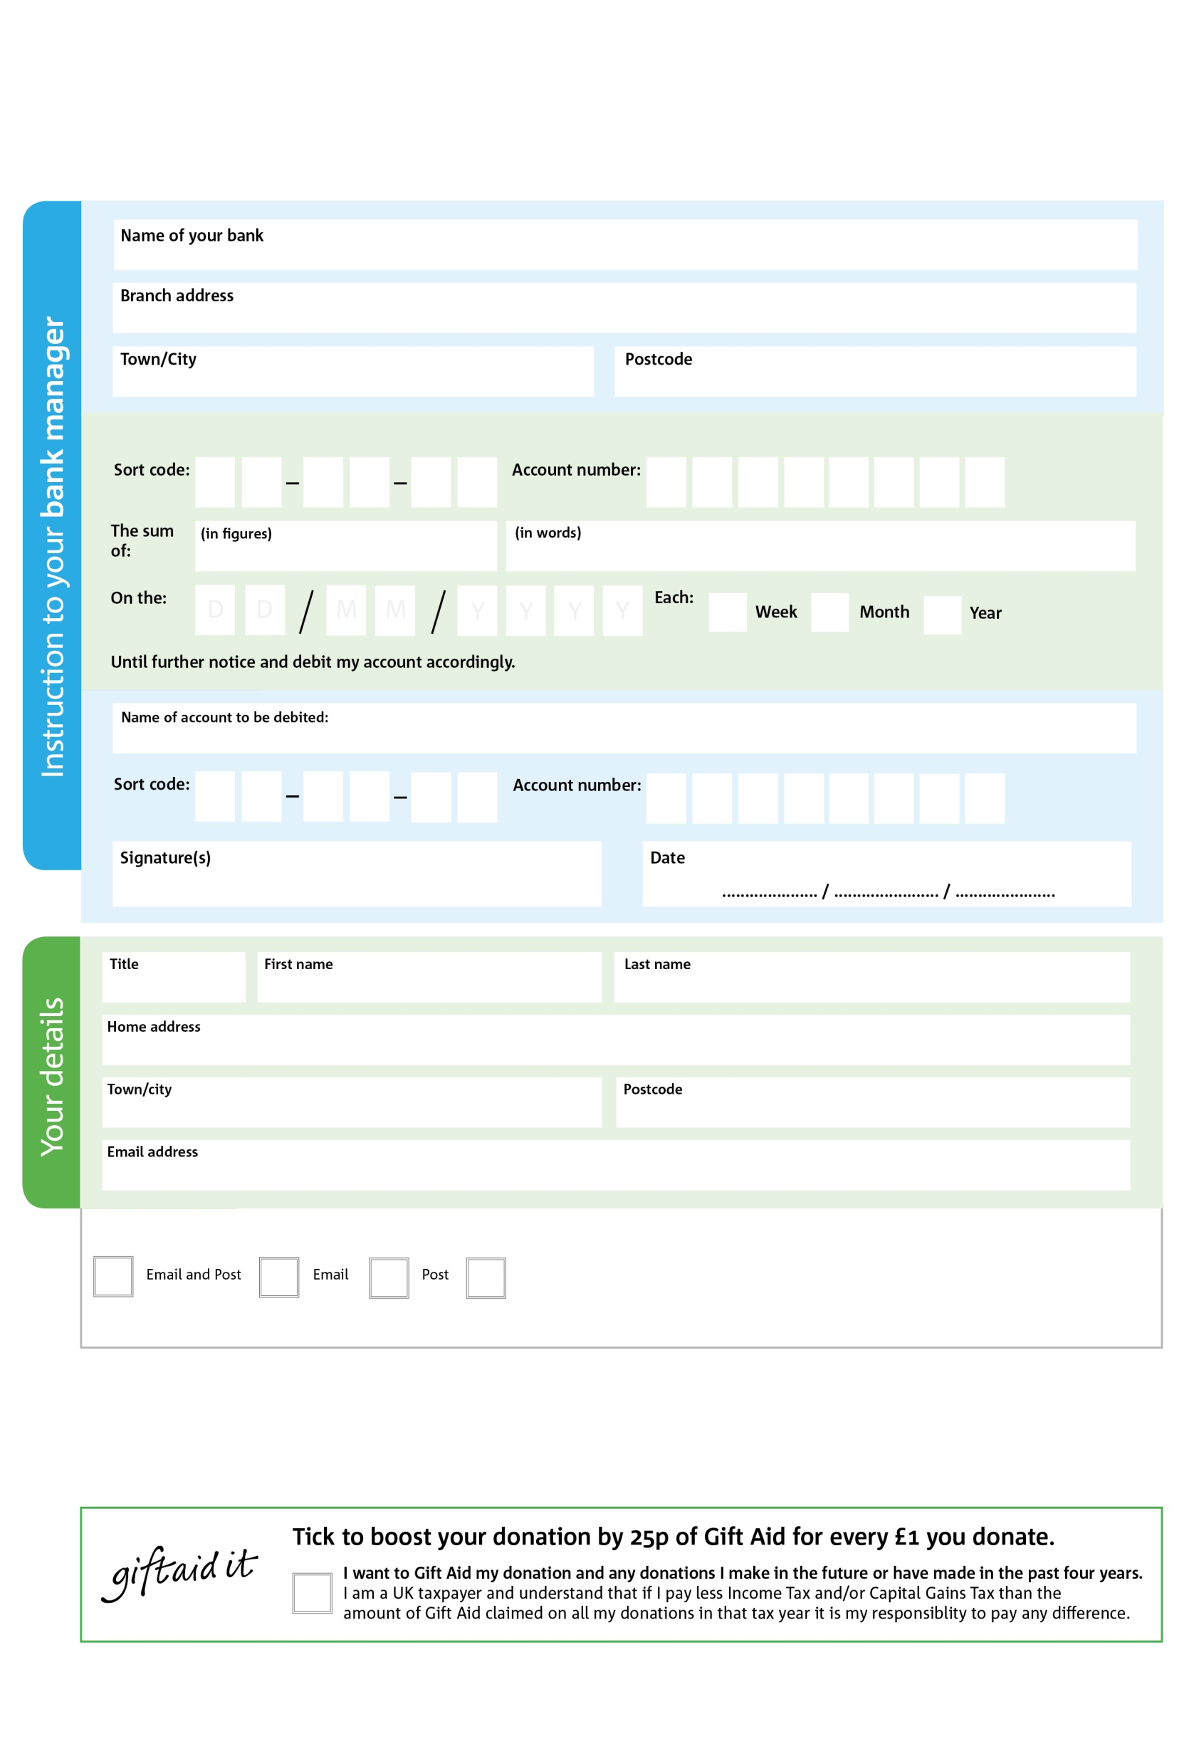

**Please pass this form onto the foodbank, using the foodbank’s address at the bottom, who will save a copy for their records. They will then send it onto your named bank or building society.**

Please pay Clevedon and District foodbank CIO cCIOOFoodbank,

**Standing Order Mandate**

**www.clevedondistrict.foodbank.org.uk**

2

V

0

V

1

V

7

V

7

V

4

V

1

V

4

V

0

5

7

1

00

4

We would love to keep you up to date with information about Clevedon and District Foodbank CIO. Please tick your preference:

You can change your preferences any time by contacting us on 07722769529 or emailing us at info@clevedondistrict.foodbank.org.uk

I do not wish to receive future communications from Clevedon and District Foodbank CIO

**Data protection**

Clevedon and District Foodbank CIO is committed to protecting your privacy and will process your personal data in accordance with the Data Protection Act 1998. Clevedon and District Foodbank CIO collects information to keep in touch with you and supply you with information relating to our work. Clevedon and District Foodbank CIO will never sell or pass your details to anyone who isn’t directly working on our behalf.

Reg. Charity No 1163153 | Reg. in England & Wales

You can change your preferences any time by contacting us on XXXXXXXXXXX or emailing us at XXXX@XXXXXXXXXX.foodbank.org.uk

I do not wish to receive future communications from XXXXXX Foodbank